

PROJECT FILE

VITYARTHI COURSE-FUNDAMENTALS OF AIML
SLOT-D21+B14+B23
FACULTY- DR. RUDRA KALYAN NAYAK

TOPIC-
Probabilistic Phishing & Malicious Text Detector

Name-Kumar Harshvardhan
Registration Number-25MIM10100

Introduction

- As part of the flipped course evaluation this project implements the subject concepts of Artificial Intelligence and Machine Learning by designing and implementing a technical solution for text classification.

- The project uses a Multinomial Naive Bayes probabilistic model to analyse and classify incoming communications as either "Safe" (Ham) or "Malicious" (Spam/Phishing).

- By transforming the raw textual data into a mathematical vector space, the system shows how historical data distributions can predict and mitigate cybersecurity threats.

Problem Statement
- Cybersecurity threats such as phishing and malicious URLs often bypass traditional security software by taking advantage in human error.

- Users and network administrators need an automated statistical tool that evaluates the probability of a message being malicious before the user interacts with it.

- The goal of this project is to identify this meaningful problem and design a technical solution and demonstrate an understanding of ML probability concepts through implementation.
Functional Requirements

- Data Ingestion & Preprocessing: The system must accept raw CSV inputs and clean the textual data (removing stop-words and punctuation) and structure the data for processing.

- Vectorization & Feature Extraction: The system must convert the cleaned text into a numerical matrix using TF-IDF (Term Frequency-Inverse Document Frequency).

- Probabilistic Classification Engine: The system must apply the Naive Bayes algorithm to calculate conditional probabilities and output a clear prediction for the user.

Non-Functional Requirements

- Performance: Text vectorization and model prediction must execute in near real-time (under 1 second) for single-string terminal inputs.

- Reliability: The model must maintain a high predictive reliability on unseen data (aiming for a baseline accuracy of over 95%).

- Error Handling Strategy: The pipeline must include an error handling strategy to gracefully manage missing inputs or strings containing unsupported characters without crashing.

- Maintainability: The code must be cleanly separated into modular files with appropriate comments and structural documentation.

System Architecture

The architecture follows a standard ML pipeline

Design Diagrams
Use Case Diagram:
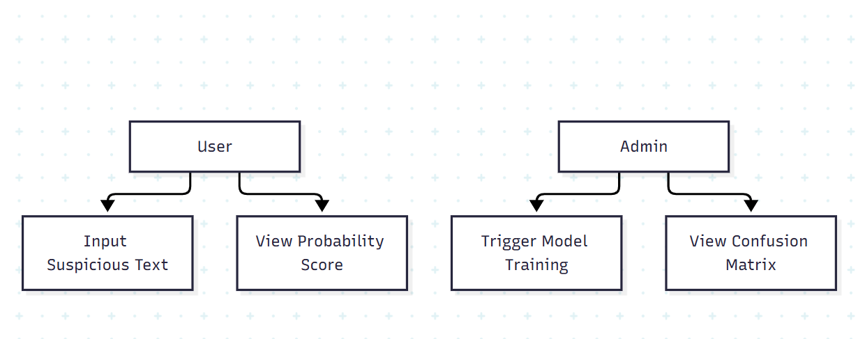

Sequence Diagram:
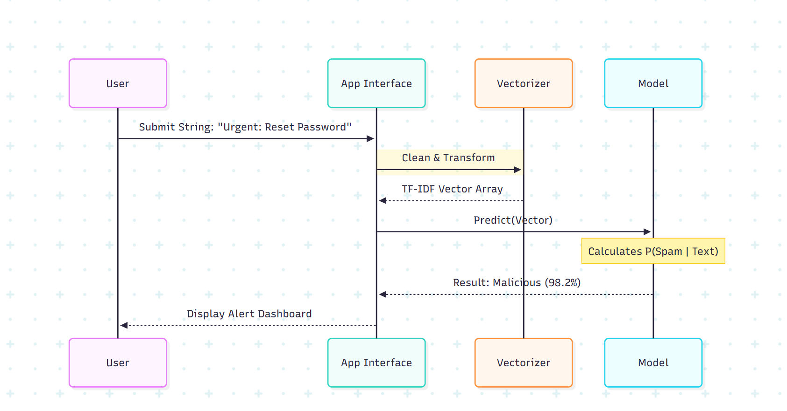
Design Decisions & Rationale

- Dataset Description: The system uses the UCI Machine Learning Repository's "SMS Spam Collection" dataset containing text messages labelled as ham or spam.

- Model Selection Rationale: Multinomial Naive Bayes was selected over deep learning due to its computational efficiency, explicit interpretability, and assumption of feature independence which performs exceptionally well on high-dimensional text data.

- Evaluation Methodology: The evaluation heavily uses the Confusion Matrix to monitor the False Positive rate (Precision) as falsely classifying a safe, urgent email is highly disruptive.

Implementation Details

The project is implemented using Python. The architecture is split into specific Python modules:

- data_preprocessing.py: Handles CSV loading and text cleaning.
- model_training.py: Instantiates and fits the Multinomial B classifier.
- evaluate.py: Generates the mathematical metrics and visualizations.
- app.py: Acts as the main execution script.
Screenshots / Results
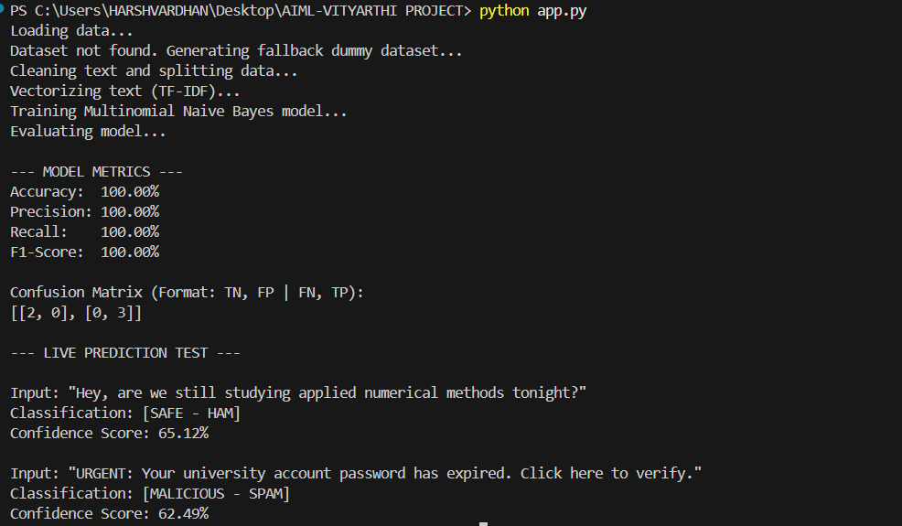

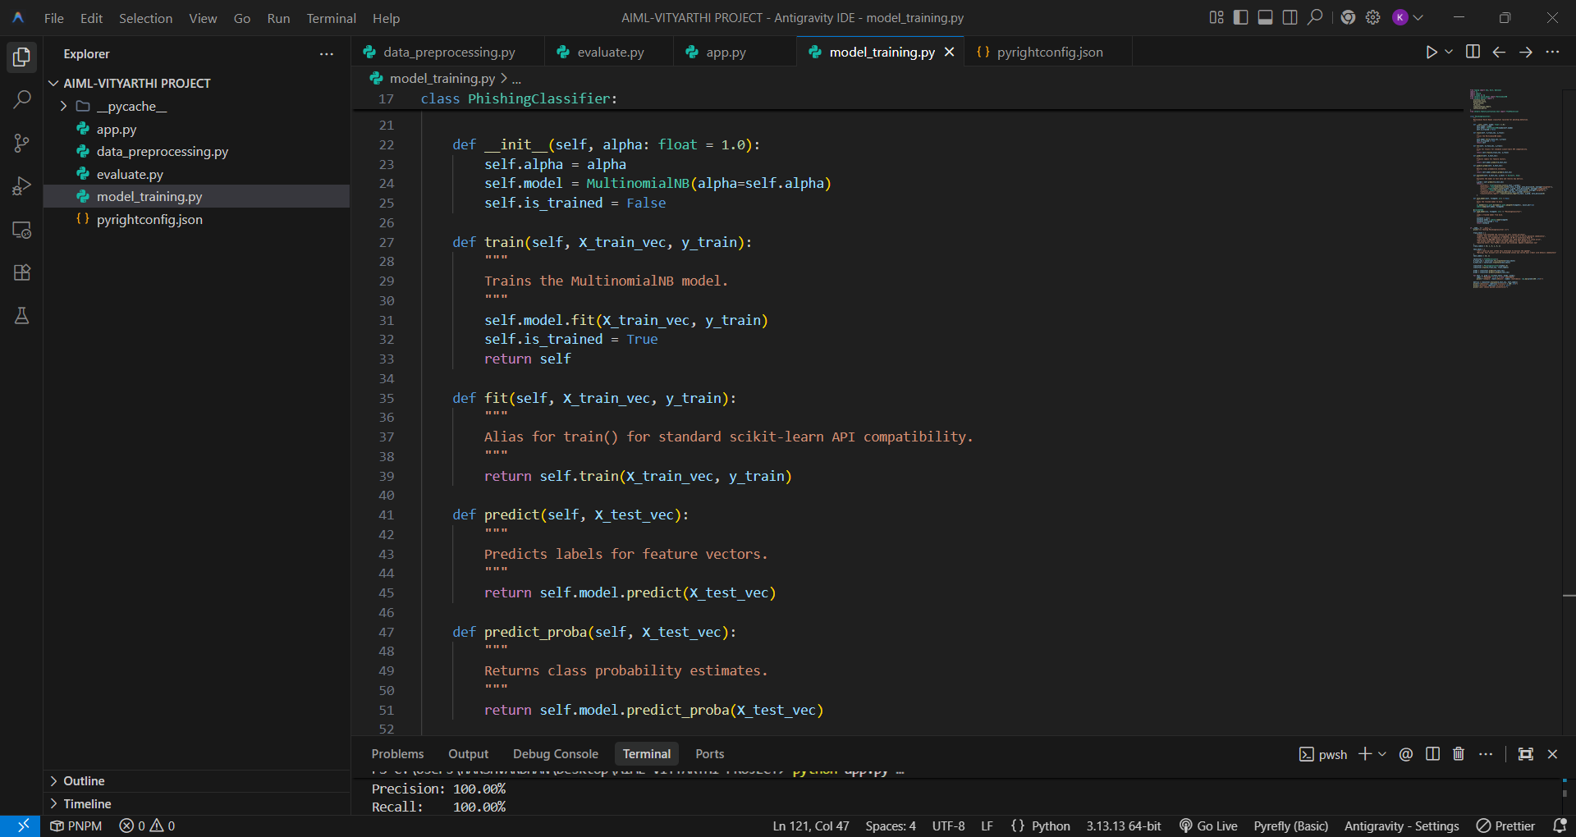
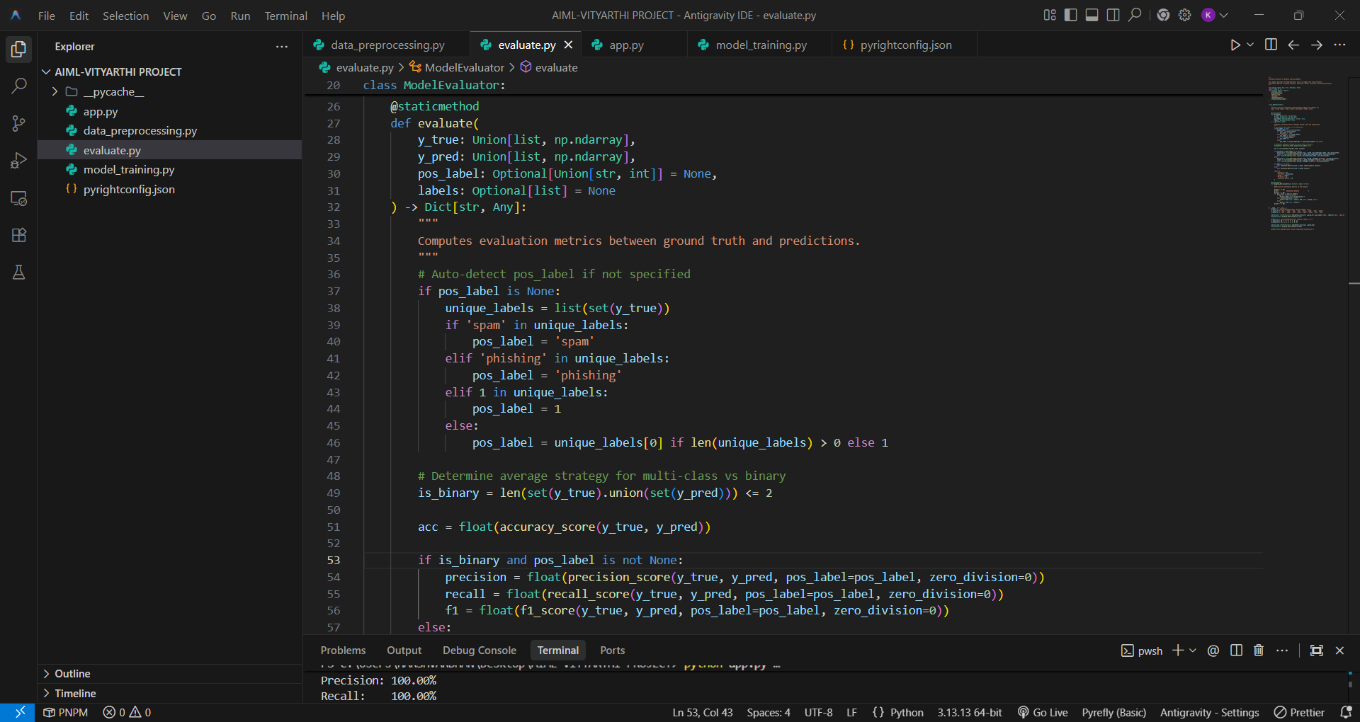
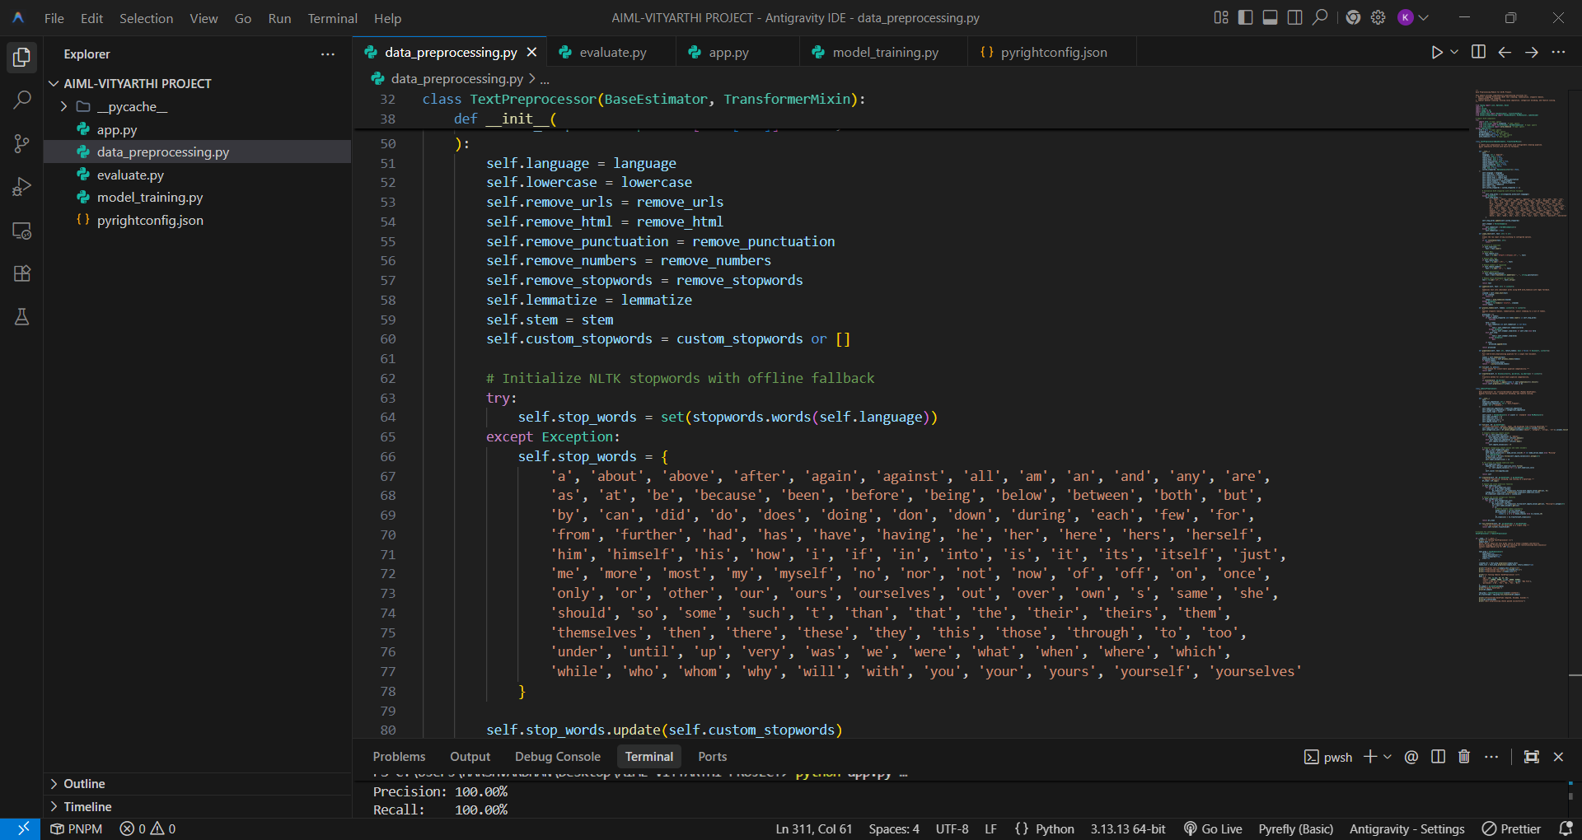

Testing Approach

- The testing approach involved splitting the dataset into an 80% training set and a 20% validation test set.
- Unit testing concepts were applied to the text cleaning module to ensure that it correctly stripped punctuation before vectorization.

Challenges Faced

- Class Imbalance: Because the majority of real-world text data is legitimate the model initially biased to predict "Safe". This was mitigated by tuning the TF-IDF parameters.

- Dimensionality: Vectorizing the text resulted in a sparse matrix with thousands of unique words. Ensuring that the predictive logic could process this efficiently without memory overflow required optimizing the data structures.

Learnings & Key Takeaways

- Demonstrated a deep understanding of how theoretical probability (Bayes' Theorem) is implemented mathematically in software architecture.

- Learned how to properly structure a machine learning pipeline, ensuring preprocessing steps applied to the training data are identically applied to the live input data.

- Recognized the importance of evaluation metrics beyond basic accuracy (e.g., Precision and Recall).

Future Enhancements

- Integrate a web scraping module to evaluate the safety of the URLs embedded within the text not just the text itself.

- Migrate the terminal-based application to a web application (like Flask) to improve graphical usability.

References

- Fundamentals of AIML Course Syllabus.

- Scikit-Learn Documentation (scikit-learn.org).

- VITyarthi Guidelines: "Build Your Own Project" Evaluation.

